STUDENT INFORMATION SYSTEM
Requirements Specification Document

Table of Contents
Table of Contents 2
1. Executive Summary 3
1.1 Project Overview 3
2. Product / Service Description 3
2.1 Product Context 3
2.2 User Characteristics 4
2.3 Assumptions 5
2.4 Constraints and Dependencies 5
3. Requirements 6
3.1 Functional Requirements 6
3.2 Non-Functional Requirements 10
3.2.1 Product Requirements 10
3.2.1.1 Usability Requirements 10
3.2.1.2 Performance Requirements 11
3.2.1.3 Availability 11
3.2.1.4 Security 12
3.2.2 Organizational Requirements 13
3.2.3 External Requirements 13
4. User Scenarios / Use Cases 14
5. Diagrams 16
5.1 Entity Relationship Diagram (ERD) 16
5.2 Use Case Diagram 16
5.3 Activity Diagrams 16
5.4 Class Diagram 16
5.5 State Diagrams 16
5.6 Sequence Diagrams 17
5.7 Collaboration Diagrams 17
6. Design Patterns 17
7. Appendix 18
7.1 Glossary of Terms 18
7.2 Organizing the Requirements 19
7.3 Document Revision History 19
7.4 Sign-Off and Approval 20

1. Executive Summary

1.1 Project Overview
The Student Information System (SIS) is a comprehensive, web-based enterprise platform designed to centralize and streamline the management of all student-related data and academic operations. The system will serve as the single authoritative source of truth for student records, enrollment, academic performance, scheduling, financial accounts, and communications across all departments, faculties, and administrative offices.

The SIS is intended to replace the current fragmented legacy systems — including separate modules for admissions, registrar functions, grade management, and billing — with a unified, integrated platform accessible via web browsers and mobile devices. This initiative is driven by the institution's strategic goal to enhance operational efficiency, improve the student experience, ensure regulatory compliance, and support data-driven decision-making at all levels of the organization.

This document defines the complete requirements — functional and non-functional — that the SIS must satisfy. It is intended for use by the project steering committee, software developers, system architects, quality assurance engineers, and all university stakeholders involved in approving, developing, and deploying the system.

2. Product / Service Description
The Student Information System is a mission-critical academic management platform that integrates the full lifecycle of student engagement — from initial application and admission, through enrollment, academic progression, financial management, and eventual graduation and alumni tracking. The system encompasses the following major functional domains:

- Admissions and Application Management
- Student Registration and Enrollment
- Academic Records and Grade Management
- Course and Curriculum Scheduling
- Financial Aid and Student Billing
- Attendance Monitoring and Reporting
- Faculty and Staff Administration
- Reporting, Analytics, and Dashboard
- Communication and Notification Services
- Alumni and Graduate Tracking

2.1 Product Context
The SIS will operate as the central hub of the university's digital ecosystem. It will interface with multiple external and internal systems, including:

- Government Reporting Portals: Automated submission of student enrollment counts, graduation rates, and demographic data to the Department of Education and accreditation bodies.
- Learning Management System (LMS): Bidirectional synchronization with the university's LMS (e.g., Moodle / Canvas) to share enrollment rosters, grade data, and course metadata.
- Enterprise Resource Planning (ERP): Integration with the university's ERP system for financial transactions, payroll of student employees, and procurement workflows.
- Library Management System: Sharing of student and faculty credentials to manage borrowing privileges and resource access.
- Identity Provider (IdP): Single Sign-On (SSO) via SAML 2.0 / OAuth 2.0 to authenticate users through the university's central identity provider.
- Email and SMS Gateway: Integration with SendGrid / Twilio for automated notifications, alerts, and communications.
- Payment Gateways: Secure payment processing via Stripe or PayPal for tuition, fees, and other financial transactions.

2.2 User Characteristics
- The following user profiles have been identified for the SIS. Each group has distinct technical expertise levels and system usage patterns:

User Type | Category | Technical Expertise | Key Characteristics
Undergraduate Student | Student | Intermediate | Ages 17–25; heavy mobile usage; expects fast, intuitive interfaces similar to consumer apps.
Graduate Student | Student | Intermediate–Advanced | Familiar with academic systems; may use research and thesis management modules.
Faculty Member | Staff | Intermediate | Manages grade submission, course materials, and attendance records.
Department Chair | Staff | Intermediate | Oversees curriculum planning, faculty assignments, and departmental reports.
Registrar Officer | Staff | Advanced | Manages course catalogues, enrollment verifications, and transcript issuance.
Finance / Bursar Officer | Staff | Intermediate | Manages tuition invoicing, payment reconciliation, and financial aid disbursement.
System Administrator | IT Staff | Expert | Manages user accounts, roles/permissions, system configuration, and technical maintenance.
University Executive | Management | Basic | Requires high-level dashboards, KPIs, and analytical reports; does not perform data entry.
Parent / Guardian | External | Basic | Limited portal access (with student consent) to view grades, attendance, and financial statements.

2.3 Assumptions
The following assumptions underlie this Requirements Specification. Changes to these assumptions may necessitate updates to the requirements:

- All users are assumed to have access to a modern web browser (Chrome, Firefox, Safari, or Edge) with JavaScript enabled.
- The university will provide a stable internet connection with minimum 100 Mbps dedicated bandwidth for server infrastructure.
- Students are assumed to possess basic digital literacy sufficient to navigate a web portal and mobile application.
- The university's existing Identity Provider (Active Directory / LDAP) will be available and maintainable for SSO integration throughout the project.
- All departments will complete a data migration exercise to clean and transfer legacy data into the SIS prior to go-live.
- The university will appoint designated data stewards in each department responsible for validating migrated data accuracy.
- Faculty members are assumed to have university-issued devices capable of supporting the SIS web interface.
- The SIS will be hosted on the university's private cloud infrastructure (AWS GovCloud or equivalent), with a dedicated DevOps team for deployment and monitoring.
- All regulatory and accreditation reporting requirements are assumed to remain stable throughout the development lifecycle; any changes will be handled via change control.

2.4 Constraints and Dependencies
The following constraints and dependencies must be considered throughout development and deployment:
- Parallel Operation: The SIS must support parallel operation alongside legacy systems for a minimum of one full academic semester (approximately 16 weeks) to allow data validation and user transition.
- Regulatory Compliance: The system must comply with FERPA (Family Educational Rights and Privacy Act), GDPR (for international students), and applicable local data protection regulations. Student records may not be disclosed without appropriate authorization.
- Accessibility: The system must conform to WCAG 2.1 Level AA accessibility standards to serve students and staff with disabilities.
- Legacy Data Migration: The Registrar's Office must complete data cleansing and migration of historical student records (dating back 10 years minimum) before the system can go live. This migration is estimated to take 8 weeks and is a predecessor to UAT.
- LMS Integration Dependency: The bidirectional sync module with the Learning Management System cannot be deployed until the LMS vendor completes their API upgrade (scheduled for Q3 2025).
- Payment Gateway Certification: PCI-DSS compliance certification must be obtained before the financial module can accept live payment card transactions.
- Budgetary Constraint: The total project budget is capped at $2.4 million USD. Any scope additions must go through a formal change control process with budget impact assessment.
- Timeline: The system must be ready for User Acceptance Testing (UAT) by December 1, 2025, with production go-live targeted for January 15, 2026 (start of Spring Semester).

3. Requirements
The following section documents all system requirements in sufficient detail for system designers to build and for testers to verify the system against each requirement. Requirements are numbered using the scheme SIS-FR-### for functional requirements and SIS-NFR-### for non-functional requirements.

Priority Definitions used throughout this section are defined as follows:

- Priority 1 (Must Have): The requirement is mandated by law, institutional policy, or is essential to core system operation. Non-compliance is not acceptable.
- Priority 2 (Should Have): The requirement significantly improves processing, user experience, or operational efficiency and is expected to deliver immediate measurable benefits.
- Priority 3 (Nice to Have): The requirement provides added value or enhanced functionality but is not critical to the initial go-live scope.

3.1 Functional Requirements
3.1.1 Student Registration and Enrollment

Req # | Requirement | Comments | Priority | Date Rvwd | SME Reviewed / Approved
SIS-FR-001 | The system shall allow students to search for available courses by department, semester, faculty, time slot, and available seats. | Course search must support partial text matching and filter combinations. | 1 | 2025-03-26 | Registrar Office
SIS-FR-002 | The system shall allow students to add and drop courses within the official add/drop period defined by the academic calendar. | System must enforce add/drop deadlines automatically. | 1 | 2025-03-26 | Registrar Office
SIS-FR-003 | The system shall enforce pre-requisite validation before allowing a student to enroll in a course, rejecting enrollment if prerequisites have not been satisfied. | Pre-requisites are defined per course in the curriculum catalogue. | 1 | 2025-03-26 | Academic Affairs
SIS-FR-004 | The system shall support waitlisting for full courses, automatically notifying waitlisted students via email and SMS when a seat becomes available. | Waitlist position must be visible to the student in real time. | 2 | 2025-03-26 | Registrar Office
SIS-FR-005 | The system shall generate and display a personalized semester schedule for each student upon enrollment confirmation. | Schedule must be exportable as PDF and importable to Google Calendar / Outlook. | 2 | 2025-03-26 | Registrar Office

3.1.2 Academic Records and Grade Management

Req # | Requirement | Comments | Priority | Date Rvwd | SME Reviewed / Approved
SIS-FR-006 | The system shall allow authorized faculty members to enter, edit, and submit final grades for all students enrolled in their courses within the grade submission window. | Grade entry must be locked after the submission deadline. Late grade changes require Department Chair approval. | 1 | 2025-03-26 | Academic Affairs
SIS-FR-007 | The system shall automatically calculate and update each student's Grade Point Average (GPA) — both semester GPA and cumulative GPA — upon final grade submission. | GPA calculation must follow the institution's approved 4.0 scale rubric. | 1 | 2025-03-26 | Academic Affairs
SIS-FR-008 | The system shall generate official academic transcripts, both official sealed transcripts and unofficial student copies, on demand. | Official transcripts must include a verifiable QR code and digital watermark. | 1 | 2025-03-26 | Registrar Office
SIS-FR-009 | The system shall maintain a complete, immutable academic history for each student, including all grades, withdrawals, incomplete grades, and academic standing records. | Academic history must be retained for a minimum of 50 years per accreditation requirements. | 1 | 2025-03-26 | Registrar / Legal
SIS-FR-010 | The system shall track and display a student's academic standing (Good Standing, Academic Probation, Academic Suspension) based on GPA thresholds defined by academic policy. | Standing changes must trigger automated notifications to the student and academic advisor. | 2 | 2025-03-26 | Academic Affairs

3.1.3 Admissions Management

Req # | Requirement | Comments | Priority | Date Rvwd | SME Reviewed / Approved
SIS-FR-011 | The system shall provide an online application portal allowing prospective students to submit applications including personal details, academic history, supporting documents, and application fee payment. | Portal must support document uploads in PDF, JPG, and PNG formats (max 10 MB per file). | 1 | 2025-03-26 | Admissions Office
SIS-FR-012 | The system shall track application status through configurable workflow stages (Submitted, Under Review, Interview Scheduled, Accepted, Rejected, Waitlisted, Enrolled). | Applicants must receive automated email updates at each stage transition. | 1 | 2025-03-26 | Admissions Office
SIS-FR-013 | The system shall generate offer letters and rejection notices from configurable templates, with digital signature capability for the Dean of Admissions. | Letters must be delivered via the applicant portal and optionally via email. | 2 | 2025-03-26 | Admissions Office
SIS-FR-014 | The system shall allow the Admissions Office to define and configure program-specific admission criteria including minimum GPA thresholds, required documents, and application deadlines. | Criteria must be versioned to support future academic year changes without affecting in-progress applications. | 2 | 2025-03-26 | Admissions / IT

3.1.4 Attendance Management

Req # | Requirement | Comments | Priority | Date Rvwd | SME Reviewed / Approved
SIS-FR-015 | The system shall allow faculty members to record attendance for each class session, marking each enrolled student as Present, Absent, or Late. | Attendance recording must be completable via mobile device for use in physical classrooms. | 1 | 2025-03-26 | Academic Affairs
SIS-FR-016 | The system shall automatically generate an alert notification to the student, the course faculty, and the academic advisor when a student's absences exceed the institution-defined threshold (default: 3 unexcused absences). | Threshold values must be configurable by faculty or department policy. | 1 | 2025-03-26 | Academic Affairs
SIS-FR-017 | The system shall generate attendance reports per course, per student, and per department, filterable by date range and exportable in Excel and PDF formats. |  | 2 | 2025-03-26 | Registrar Office

3.1.5 Financial and Billing Management

Req # | Requirement | Comments | Priority | Date Rvwd | SME Reviewed / Approved
SIS-FR-018 | The system shall automatically generate tuition invoices for each enrolled student at the start of each semester, itemizing tuition per credit hour, mandatory fees, and optional fees. | Invoices must be accessible in the student portal within 24 hours of enrollment confirmation. | 1 | 2025-03-26 | Finance / Bursar
SIS-FR-019 | The system shall allow students to pay outstanding balances online via credit card, debit card, or bank transfer through the integrated payment gateway (PCI-DSS compliant). | Payment receipts must be automatically emailed and downloadable as PDF. | 1 | 2025-03-26 | Finance / Bursar
SIS-FR-020 | The system shall support financial aid disbursement workflows, including tracking of scholarship awards, grant allocations, and loan processing, with integration to the federal aid portal (FAFSA data import). |  | 1 | 2025-03-26 | Financial Aid Office
SIS-FR-021 | The system shall apply a registration hold to any student with an outstanding balance exceeding a configurable threshold, preventing course enrollment until the balance is resolved. | Hold placement and removal must be auditable with a timestamped log. | 1 | 2025-03-26 | Finance / Bursar
SIS-FR-022 | The system shall allow the Finance Office to configure and manage payment plans, installment schedules, and late payment penalties with automatic calculation and application. |  | 2 | 2025-03-26 | Finance / Bursar

3.1.6 Reporting and Analytics

Req # | Requirement | Comments | Priority | Date Rvwd | SME Reviewed / Approved
SIS-FR-023 | The system shall provide a real-time executive dashboard displaying key institutional KPIs including total enrollment, retention rate, graduation rate, GPA distribution, and financial summary. | Dashboard widgets must be configurable per user role. | 1 | 2025-03-26 | Executive / IT
SIS-FR-024 | The system shall allow authorized administrators to create custom reports by selecting data fields, filters, groupings, and date ranges from a report builder interface. | Custom reports must be saveable and schedulable for automated periodic delivery via email. | 2 | 2025-03-26 | All Departments
SIS-FR-025 | The system shall produce required government and accreditation compliance reports (e.g., IPEDS, SEVIS for international students) in the mandated formats. | Compliance reports must be auditable and must carry a digital submission timestamp. | 1 | 2025-03-26 | Registrar / Legal

3.2 Non-Functional Requirements

3.2.1 Product Requirements

3.2.1.1 Usability Requirements

Req # | Requirement | Comments | Priority | Date Rvwd | SME Reviewed / Approved
SIS-NFR-001 | The system shall adhere to WCAG 2.1 Level AA accessibility guidelines, ensuring full usability by individuals with visual, auditory, motor, or cognitive disabilities. | Includes screen reader compatibility (NVDA, JAWS), keyboard navigation, and ARIA attributes. | 1 | 2025-03-26 | IT / Accessibility Office
SIS-NFR-002 | New users (students and faculty) shall be able to complete their most common tasks (course enrollment for students; grade submission for faculty) without formal training, relying only on in-system guidance and tooltips. | Measured via usability testing: 90% of participants complete tasks within 10 minutes without assistance. | 2 | 2025-03-26 | UX Team
SIS-NFR-003 | The system shall provide context-sensitive help documentation and an in-app guided tour for first-time users, covering all major functional modules. |  | 2 | 2025-03-26 | UX / Documentation Team
SIS-NFR-004 | The system interface shall be fully responsive, supporting screen resolutions from 320px (mobile) to 2560px (4K desktop) without loss of functionality. |  | 1 | 2025-03-26 | Development Team

3.2.1.2 Performance Requirements

Req # | Requirement | Comments | Priority | Date Rvwd | SME Reviewed / Approved
SIS-NFR-005 | 95% of all page load requests shall complete within 2 seconds under normal operating conditions (up to 500 concurrent users). | Measured with a 1 Gbps server uplink, standard database queries, no cache miss. | 1 | 2025-03-26 | IT Infrastructure
SIS-NFR-006 | The system shall support a minimum of 5,000 concurrent authenticated users during peak enrollment periods without degradation in response time beyond 4 seconds. | Load testing must be conducted to validate this threshold prior to go-live. | 1 | 2025-03-26 | IT Infrastructure
SIS-NFR-007 | Database query response times for standard student record lookups shall not exceed 500 milliseconds for 99% of transactions. | Complex analytics queries may take up to 10 seconds with user-facing progress indicators. | 2 | 2025-03-26 | IT / Database Team
SIS-NFR-008 | Report generation for datasets of up to 50,000 records shall complete within 30 seconds. Larger datasets shall be queued as background jobs with email notification upon completion. |  | 2 | 2025-03-26 | IT / Development Team

3.2.1.3 Availability

Req # | Requirement | Comments | Priority | Date Rvwd | SME Reviewed / Approved
SIS-NFR-009 | The system shall maintain a minimum uptime of 99.5% during the academic year (August through May), excluding pre-approved scheduled maintenance windows. | Planned downtime must be announced at least 72 hours in advance via email and in-system banner. | 1 | 2025-03-26 | IT Infrastructure
SIS-NFR-010 | The system shall achieve 100% availability (zero downtime) during critical academic periods: the first two weeks of each semester (enrollment period) and the final grade submission week. | Any maintenance required during these periods must obtain executive approval. | 1 | 2025-03-26 | IT / Registrar
SIS-NFR-011 | The maximum acceptable unplanned downtime (MTTR — Mean Time to Recovery) for any production incident shall not exceed 4 hours. | An on-call support rotation must be maintained by IT Operations. | 1 | 2025-03-26 | IT Operations
SIS-NFR-012 | The system shall provide a geographically redundant disaster recovery site capable of restoring full operations within 8 hours of a primary site failure (RTO: 8 hours; RPO: 1 hour). | Recovery procedures must be documented and tested semi-annually. | 1 | 2025-03-26 | IT Infrastructure

3.2.1.4 Security

Req # | Requirement | Comments | Priority | Date Rvwd | SME Reviewed / Approved
SIS-NFR-013 | All data in transit shall be encrypted using TLS 1.2 or higher. All data at rest (databases, backups, file storage) shall be encrypted using AES-256. | SSL certificates must be from a trusted CA and must be renewed before expiry. | 1 | 2025-03-26 | IT Security
SIS-NFR-014 | The system shall implement Role-Based Access Control (RBAC) with a minimum of 8 predefined roles (Student, Faculty, Registrar Officer, Department Chair, Finance Officer, Financial Aid Officer, System Administrator, University Executive). Access to any module or data object shall be governed by the user's assigned role. | The principle of least privilege must be enforced. Role assignments require IT Admin approval. | 1 | 2025-03-26 | IT Security
SIS-NFR-015 | The system shall enforce Multi-Factor Authentication (MFA) for all staff and faculty accounts. Student MFA shall be strongly encouraged and optionally enforceable by institutional policy. | Supported MFA methods: Authenticator app (TOTP), SMS OTP, hardware security key (FIDO2). | 1 | 2025-03-26 | IT Security
SIS-NFR-016 | The system shall log all access to student records, including the user ID, timestamp, action performed, and the record accessed. Audit logs shall be immutable, tamper-evident, and retained for a minimum of 7 years. | Audit log exports must be available to authorized compliance officers on demand. | 1 | 2025-03-26 | IT Security / Legal
SIS-NFR-017 | The system shall automatically lock any user account after 5 consecutive failed login attempts and notify the user and IT Security team via email. | Lockout duration: 30 minutes auto-unlock, or immediate unlock by IT Admin. | 1 | 2025-03-26 | IT Security
SIS-NFR-018 | The system shall undergo an annual third-party penetration test and vulnerability assessment. All critical and high-severity findings must be remediated within 30 days of the report. |  | 1 | 2025-03-26 | IT Security / Executive

3.2.2 Organizational Requirements
The SIS development and deployment must conform to the following organizational standards and procedures:

- The system must be developed following the university's IT Governance Framework and adhere to the approved Software Development Lifecycle (SDLC) methodology (Agile Scrum with 2-week sprints).
- All system documentation — including technical specifications, user manuals, and API documentation — must be maintained in the university's Confluence workspace and version-controlled in Git.
- Change requests to this Requirements Specification must follow the university's formal Change Control Process, requiring sign-off from the Project Steering Committee before implementation.
- Training materials and onboarding programs must be developed for each user class (students, faculty, administrative staff) and made available no later than 4 weeks before the go-live date.
- A dedicated Help Desk tier (Level 1 support) must be established and trained to handle SIS-related queries before go-live, with an escalation path to the IT Development team for Level 2/3 issues.

3.2.3 External Requirements
The following external regulatory and interoperability requirements must be satisfied:

- FERPA Compliance: The system must enforce FERPA regulations at all times. Students must be able to view their own records, grant or revoke parental access, and request corrections to their records. No student data may be disclosed to third parties without written consent or a valid FERPA exception.
- GDPR Compliance: For students who are citizens or residents of the European Union, the system must provide mechanisms for data subject rights: right of access, right of rectification, right of erasure (where legally permissible), and right to data portability.
- SEVIS Compliance: The system must generate and submit accurate Student and Exchange Visitor Information System (SEVIS) reports for all international students on F-1 and J-1 visas, in the format mandated by the Department of Homeland Security.
- IPEDS Reporting: The system must produce annual Integrated Postsecondary Education Data System (IPEDS) reports covering enrollment, completions, graduation rates, finance, and human resources data, in the formats required by the National Center for Education Statistics (NCES).
- PCI-DSS Compliance: The financial module's payment processing functions must comply with Payment Card Industry Data Security Standard (PCI-DSS) Level 1. Cardholder data must never be stored in the SIS database; tokenization through the payment gateway is mandatory.

4. User Scenarios / Use Cases
The following use cases describe the most significant interactions between system actors and the SIS. Each use case is mapped to the functional requirements it satisfies.

UC_01 — Student Course Enrollment
Use Case ID | UC_01
Related Req. | SIS-FR-001, SIS-FR-002, SIS-FR-003, SIS-FR-004, SIS-FR-005
Actor(s) | Student, System (Automated Validation Engine)
Description | A registered student logs into the SIS portal and selects courses for the upcoming semester. The system validates eligibility (pre-requisites, standing, financial holds), confirms available seats, registers the student, updates their schedule, and generates a billing invoice.
Preconditions | Student account is active. Enrollment period is open. Student has no registration holds.
Main Flow | 1. Student logs in via SSO. 2. Navigates to 'Course Registration.' 3. Searches for desired course. 4. System validates pre-requisites and seat availability. 5. Student confirms selection. 6. System registers the student and updates their schedule. 7. Billing module generates a tuition invoice.
Alternative Flow | If the course is full, the student is offered a place on the waitlist. If a prerequisite is unmet, the system displays the specific missing requirement and suggests alternatives.
Postconditions | Student is enrolled in the selected course. Schedule is updated. Invoice is generated and visible in the student's financial portal.
Success Metrics | Enrollment completed in under 3 minutes. Zero enrollment errors due to system miscalculation.

UC_02 — Faculty Grade Submission
Use Case ID | UC_02
Related Req. | SIS-FR-006, SIS-FR-007, SIS-FR-008
Actor(s) | Faculty Member, Department Chair (approver), System
Description | A faculty member logs into the SIS at the end of a semester to enter final grades for all students in their course roster. The system validates entries, calculates GPA updates, and locks the grade book after the submission deadline.
Preconditions | Faculty is assigned as the instructor of record for the course. Grade submission window is open.
Main Flow | 1. Faculty logs in and navigates to 'Grade Submission.' 2. Selects course from active roster. 3. Enters a letter grade for each student. 4. Reviews and confirms submission. 5. System calculates GPA updates and sends confirmation. 6. Grade book is locked at deadline.
Alternative Flow | If a grade change is needed after the deadline, faculty submits a Grade Change Request requiring Department Chair approval. The change is applied only upon approval and creates an audit trail entry.
Postconditions | Grades are saved and visible to students. GPA is updated. Academic standing is re-evaluated.
Success Metrics | Grade submission available to student within 24 hours. GPA calculation accuracy rate: 100%.

UC_03 — Admissions Application Processing
Use Case ID | UC_03
Related Req. | SIS-FR-011, SIS-FR-012, SIS-FR-013, SIS-FR-014
Actor(s) | Prospective Student (Applicant), Admissions Officer, Dean of Admissions
Description | A prospective student submits an online application through the SIS admissions portal. The Admissions Officer reviews the application, requests additional documents if needed, and advances the application through decision stages until an offer letter or rejection notice is issued.
Preconditions | Application window is open. Applicant has created a guest account.
Main Flow | 1. Applicant completes online form and uploads documents. 2. Pays application fee via payment gateway. 3. System assigns application ID and notifies Admissions Officer. 4. Officer reviews and updates status. 5. Dean of Admissions issues offer or rejection. 6. System sends automated notification to applicant.
Alternative Flow | If required documents are missing, the system automatically emails the applicant with a document checklist and a deadline for submission.
Postconditions | Application status is updated. Applicant is notified. Accepted applicants are converted to enrolled student records.
Success Metrics | Application acknowledgment email sent within 5 minutes. Offer/rejection notification within 24 hours of decision entry.

5. Diagrams
The following subsections define all required system diagrams for the Student Information System. Diagrams follow the naming conventions established in Section 4 (Use Cases) and are to be produced and maintained by the development team in a diagramming tool (e.g., Lucidchart, draw.io, or PlantUML) and attached as appendices to this document.

5.1 Activity Diagrams
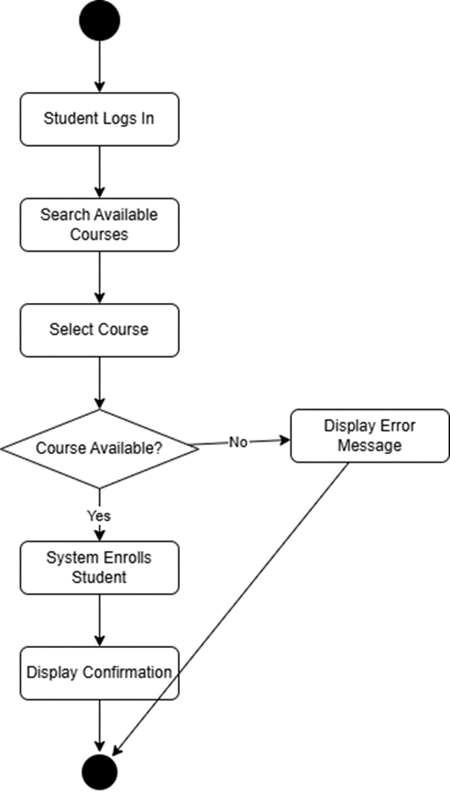
This activity diagram shows the process of a student enrolling in a course. The student logs in, searches for available courses and selects one. The system then checks if the course has available spots — if yes, the student is enrolled and receives a confirmation. If not, an error message is displayed.

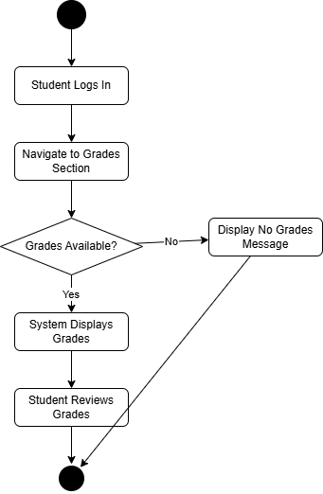
This diagram shows how a student views their grades. After logging in, the student navigates to the grades section. The system checks if grades are available — if yes, they are displayed for the student to review. If no grades exist yet, the system shows an appropriate message.

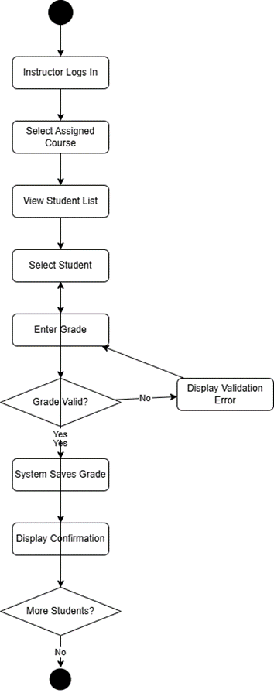

This diagram shows the grade recording process from the instructor's side. The instructor logs in, selects a course, and picks a student from the list. They enter a grade which the system validates — if invalid, the instructor is asked to re-enter it. Once saved, the instructor can continue grading other students or finish.

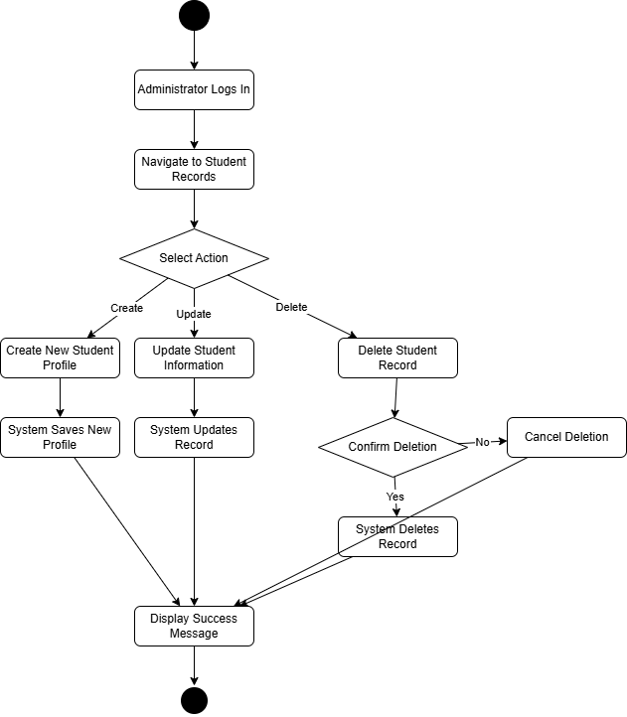

This diagram covers the three main actions an administrator can perform on student records — create, update, or delete. For deletion specifically, the system asks for confirmation before proceeding to prevent accidental data loss. All actions end with a success message.

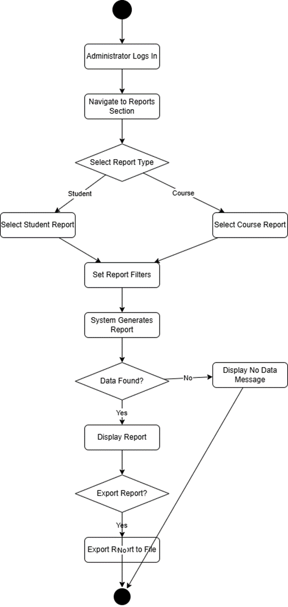
This diagram shows the report generation process. The administrator selects either a student report or a course report, applies filters, and the system generates it. If data is found it is displayed, otherwise a no-data message appears. The administrator can also choose to export the report to a file.

5.2 State Diagrams

Course state diagram

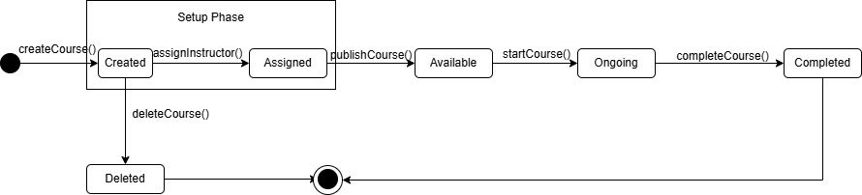

Finance state diagram

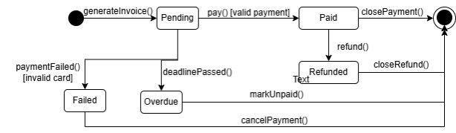

Grade state diagram

Enrollment state

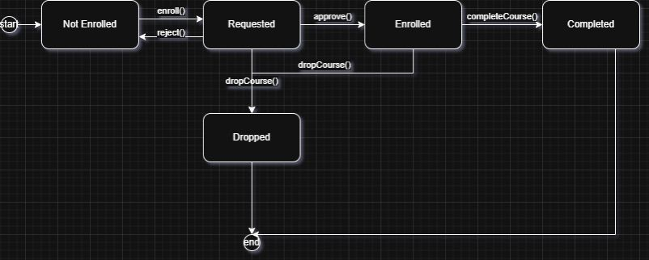

Student state

